CONSOLIDATED EXAM QUESTIONS

CHEMICAL REACTIONS
Contents
CONSOLIDATED EXAM QUESTIONS 1
CHEMICAL REACTIONS 1
Syllabus 2
Molar Mass – 9.1-9.3 3
2017 S1 3
2017 S2 3
2020 S1 3
2020 S2 3
2023 S1 3
2023 S2 3
Percentage Composition - 9.4 4
2017 S1 4
2017 S2 4
2020 S1 4
2020 S2 4
2023 S1 4
2023 S2 4
Thermochemical Equations - Exothermic and Endothermic Reactions, Enthalpy – 10.1-10.2 6
2017 S1 6
2017 S2 8
2020 S1 9
2020 S2 9
2023 S1 10
2023 S2 10
Fuel and Combustion Reactions – 11.1-11.3 11
2017 S1 11
2017 S2 15
2020 S1 15
2020 S2 15
2023 S1 15
2023 S2 15
Other Chemical Reactions 17
2017 S1 17
2017 S2 17
2020 S1 17
2020 S2 17
2023 S1 17
2023 S2 17

Syllabus
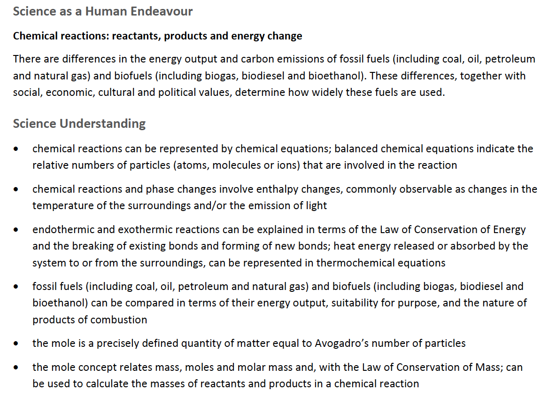

Molar Mass – 9.1-9.3

2017 S1

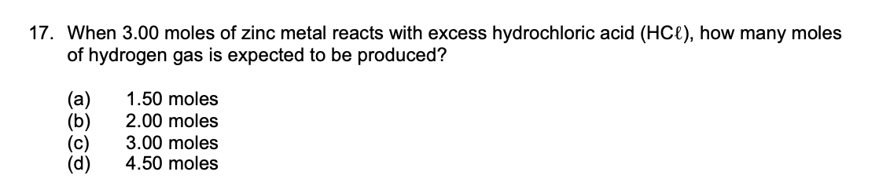
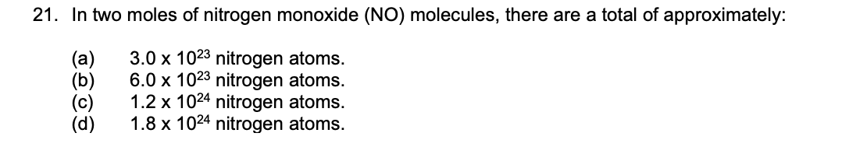

2017 S2

2020 S1

2020 S2

2023 S1

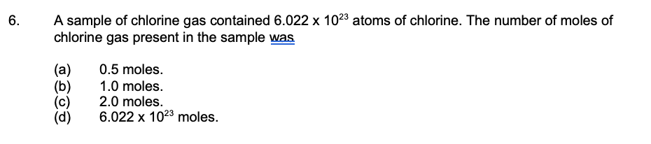

2023 S2

Percentage Composition - 9.4

2017 S1
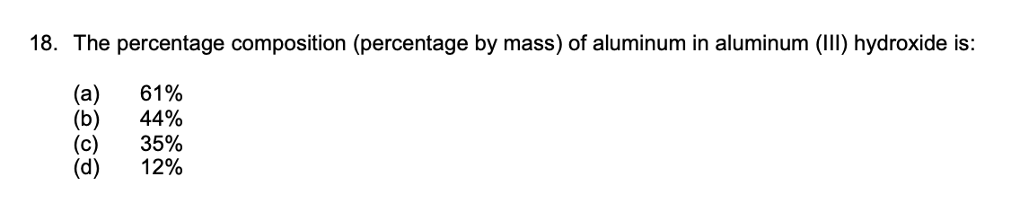

2017 S2

2020 S1

2020 S2

2023 S1

2023 S2

Thermochemical Equations - Exothermic and Endothermic Reactions, Enthalpy – 10.1-10.2

2017 S1
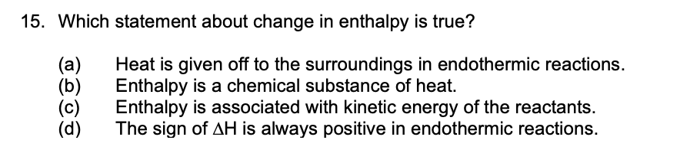

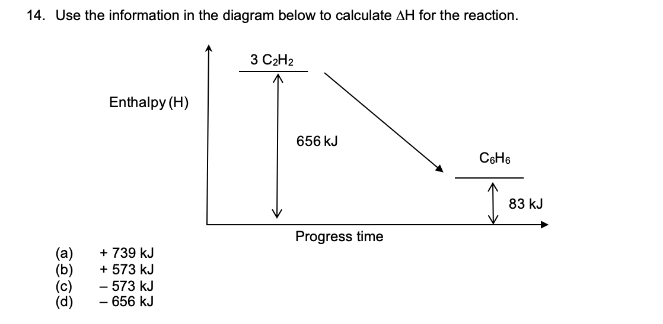
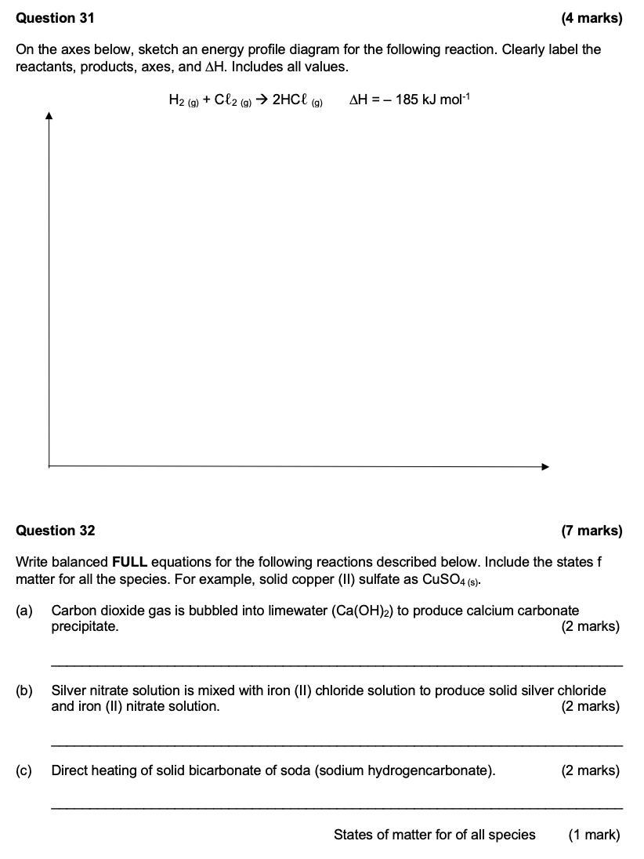

2017 S2

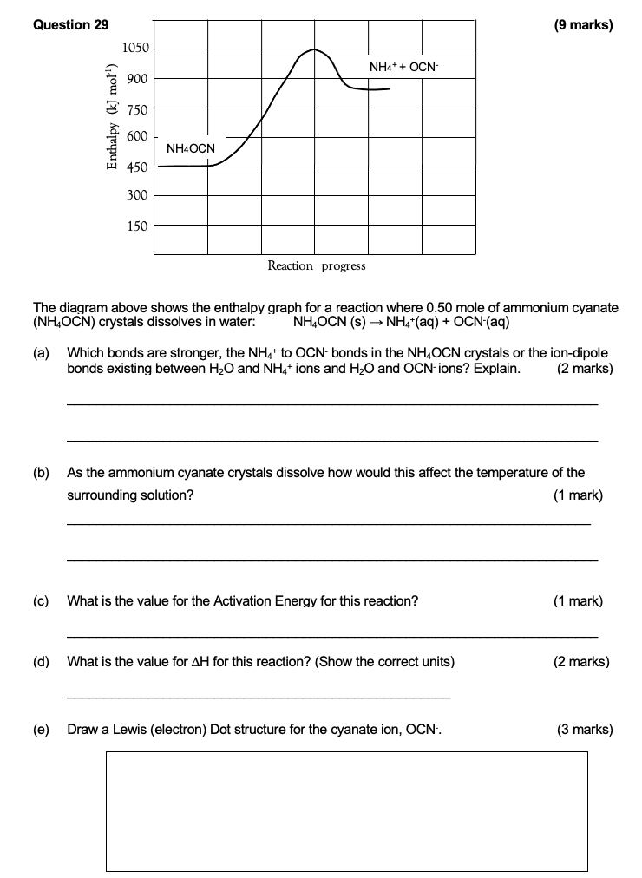

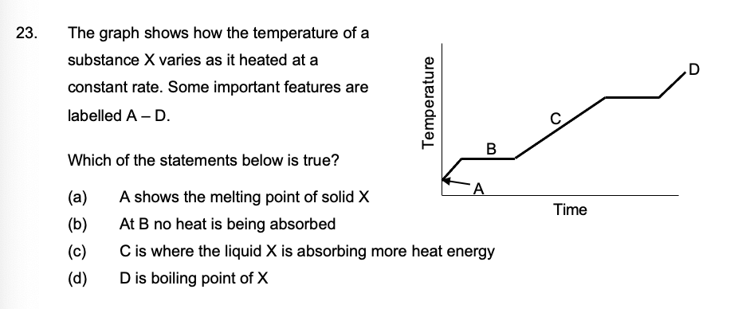

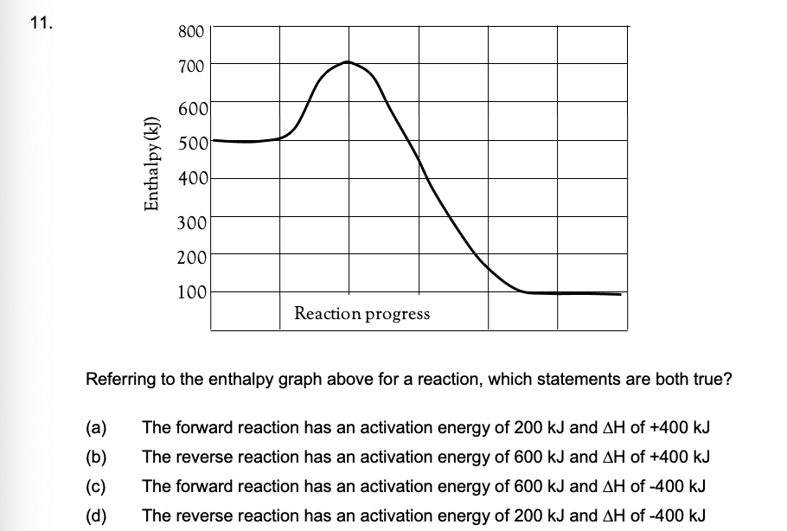

2020 S1

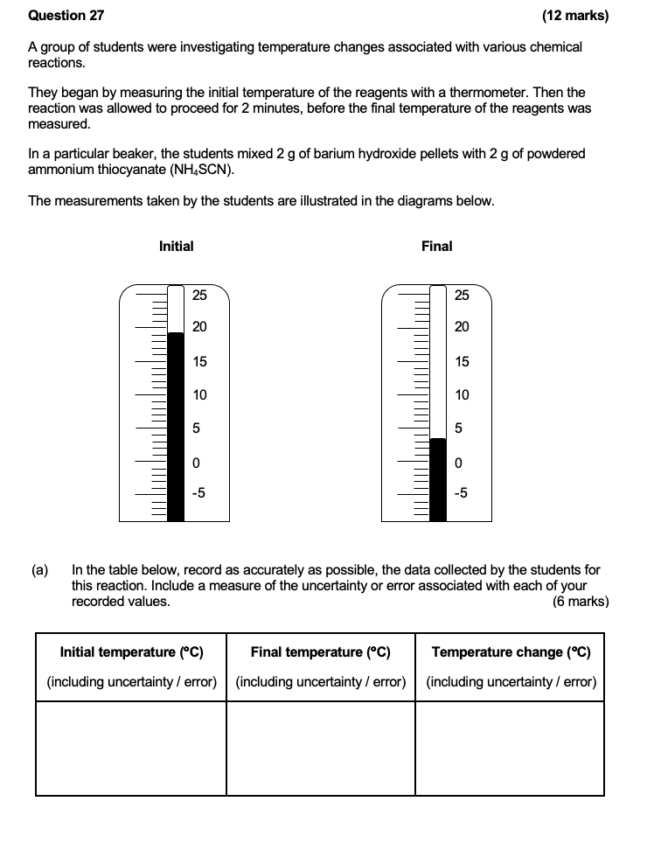
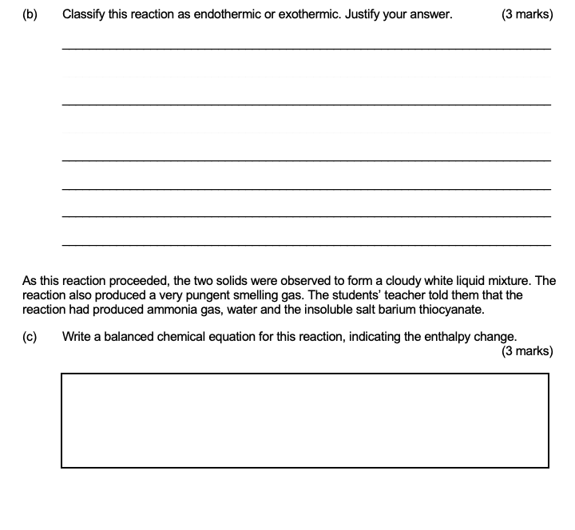

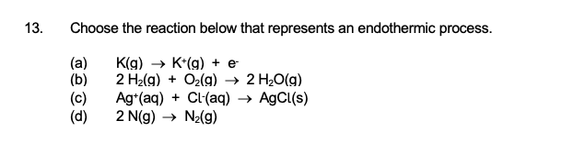
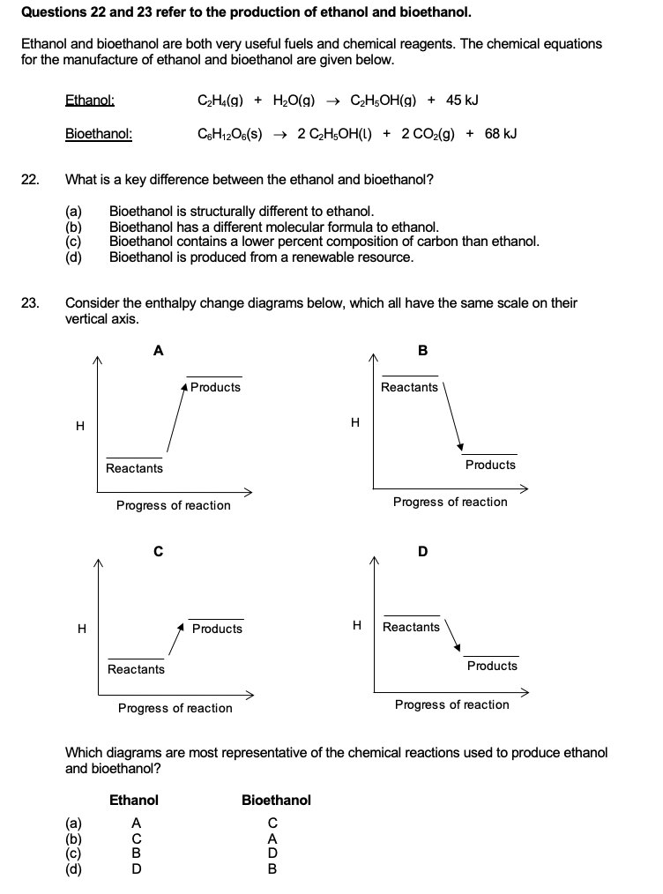

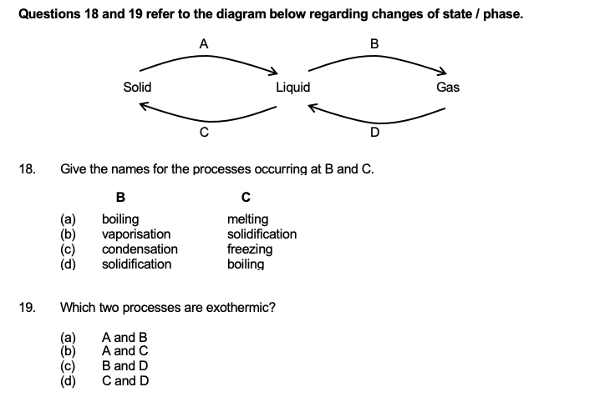

2020 S2

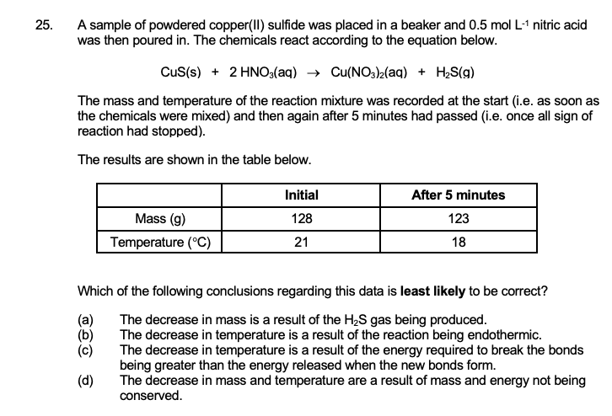

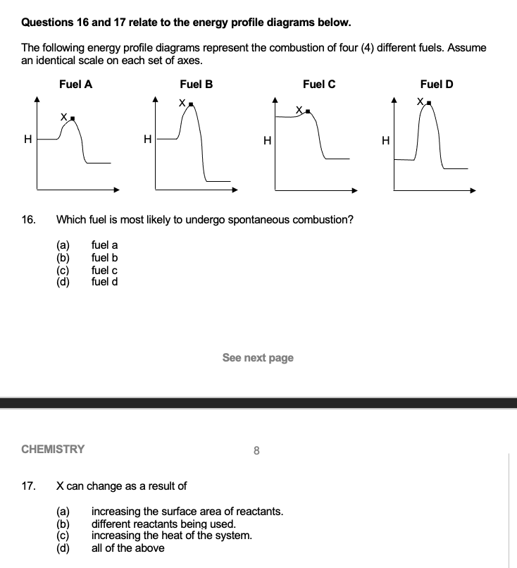

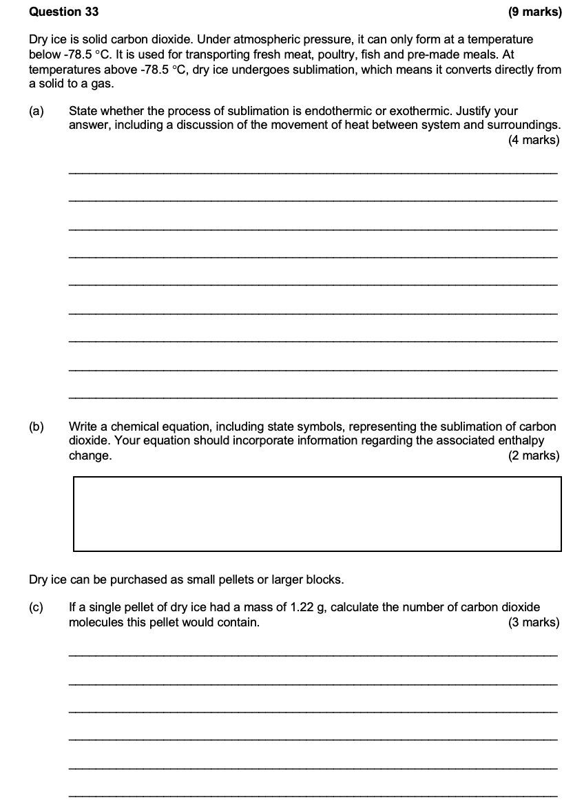

2023 S1

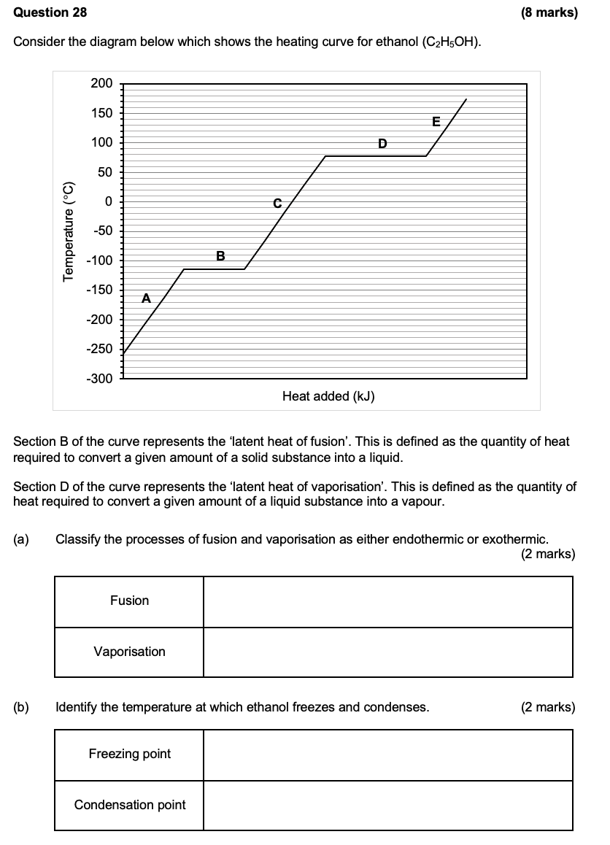

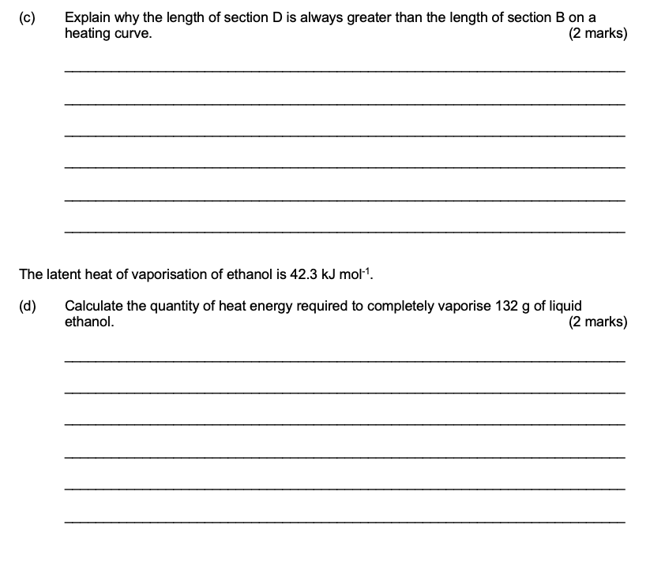
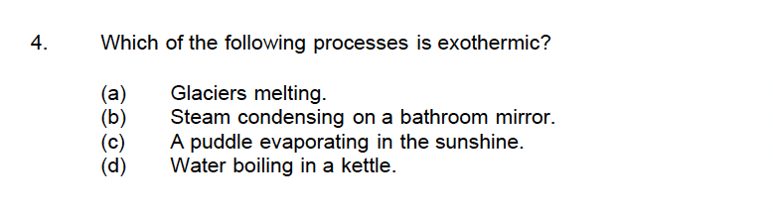

2023 S2

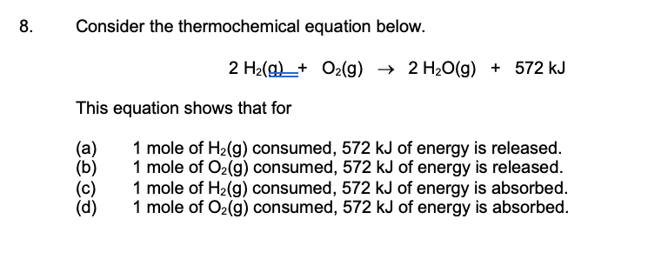

Fuel and Combustion Reactions – 11.1-11.3

2017 S1

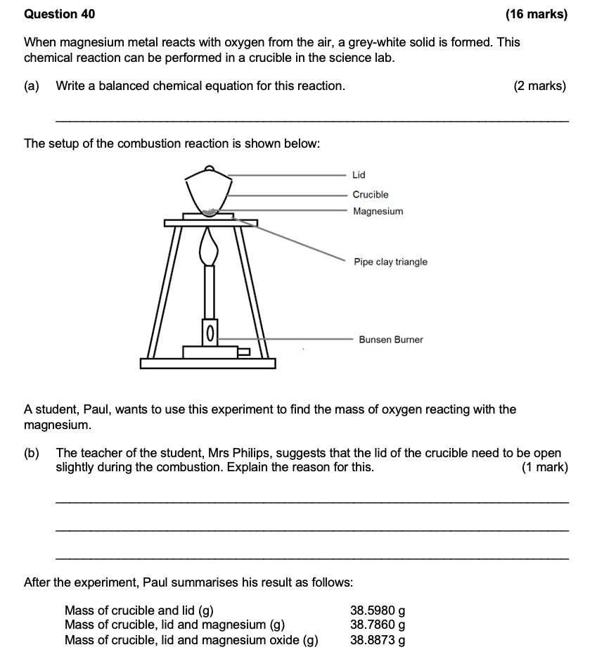
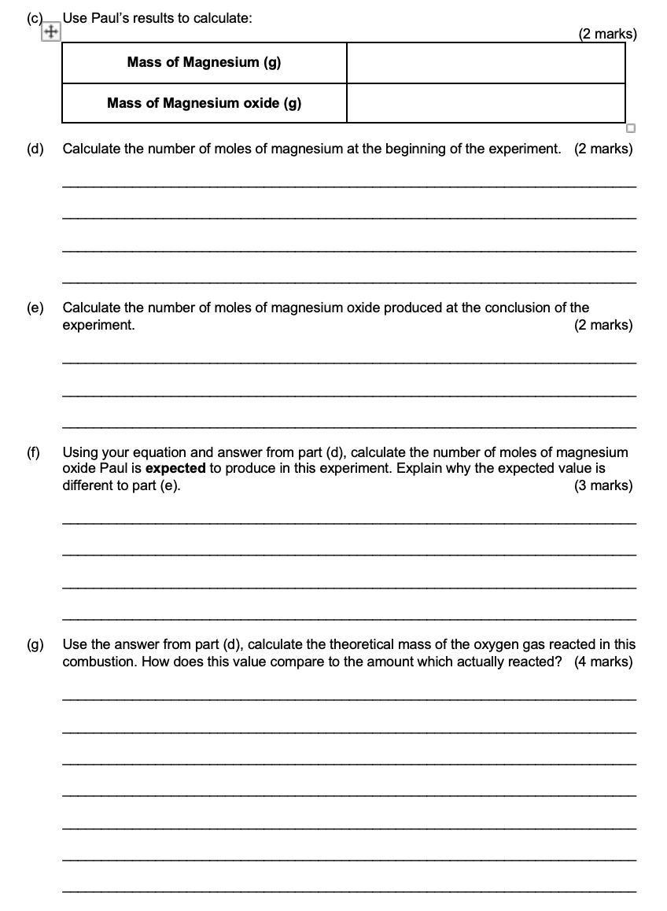

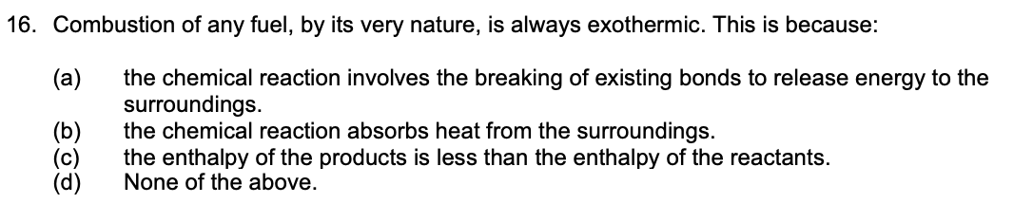
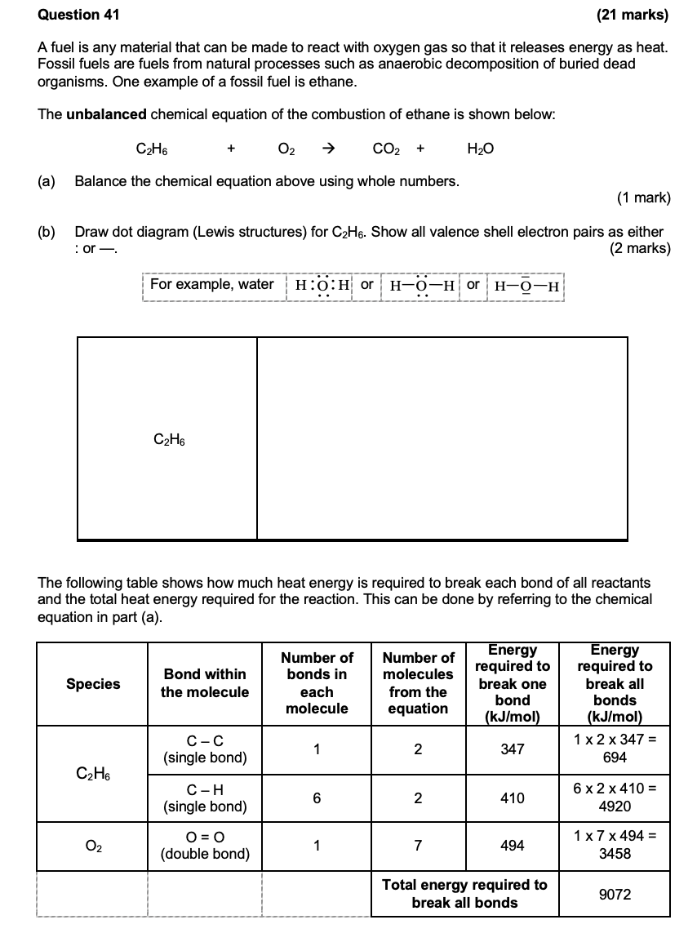

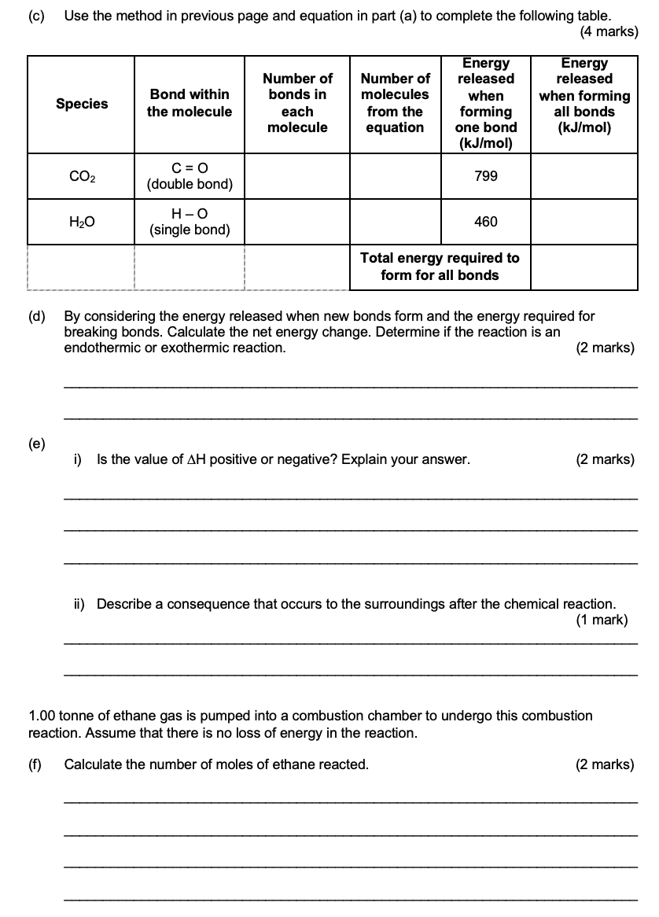

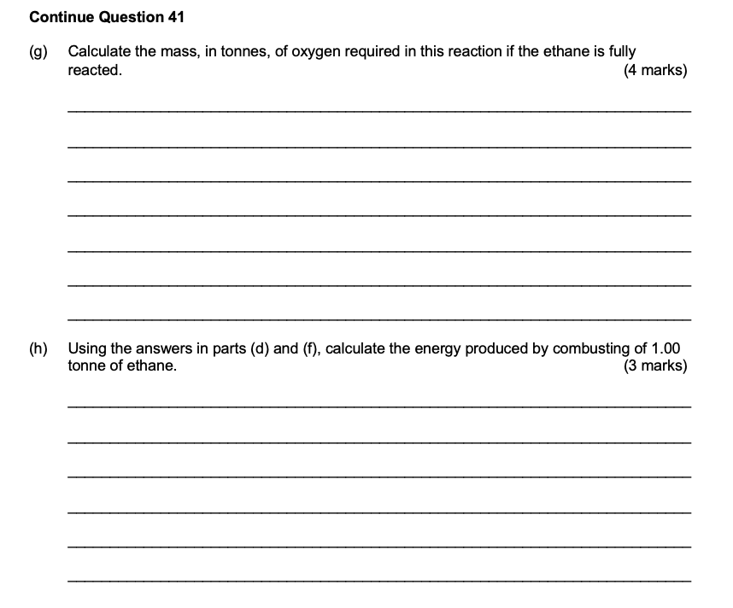

2017 S2

2020 S1
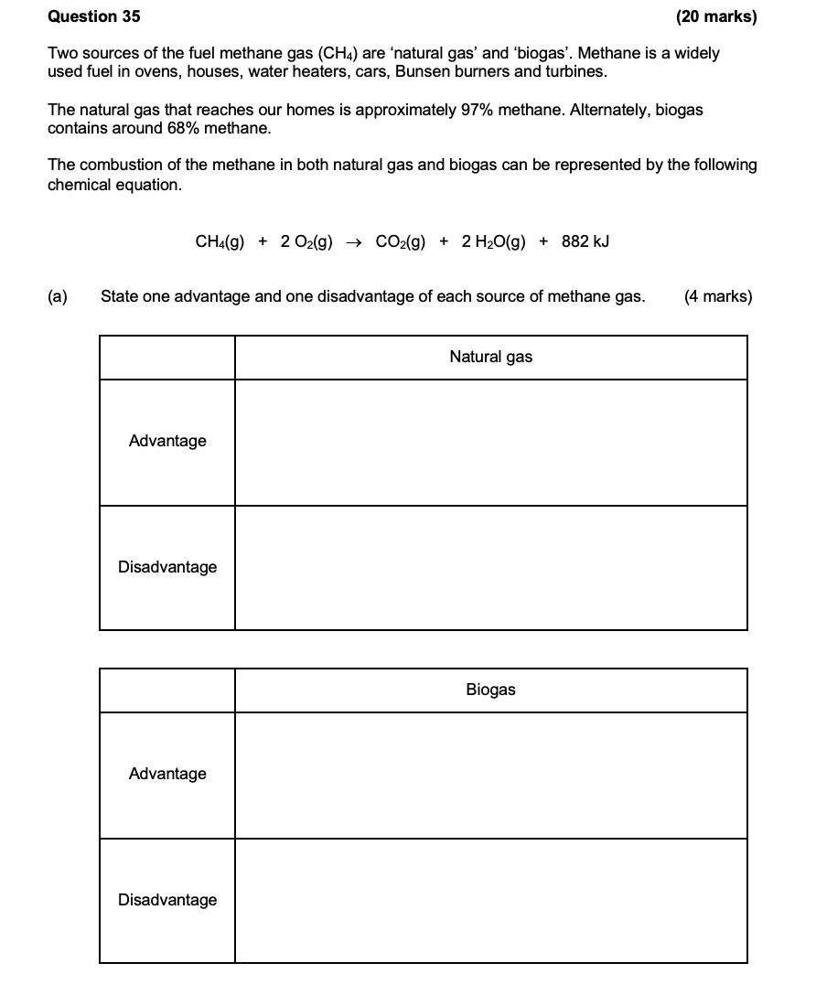
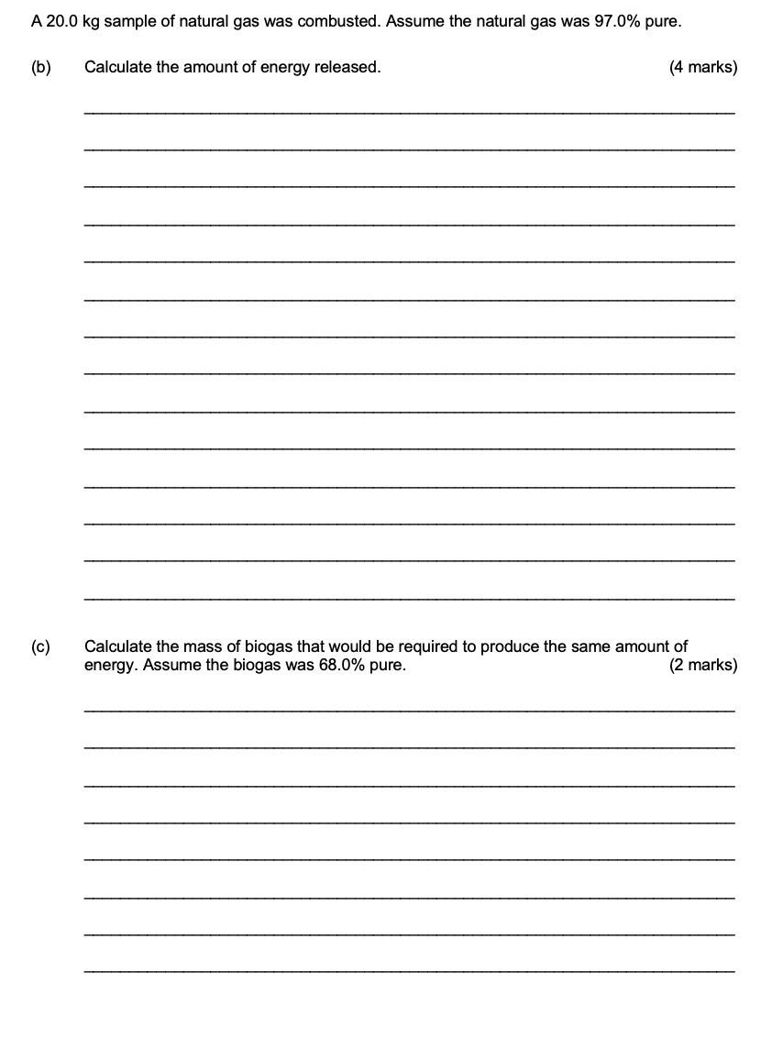
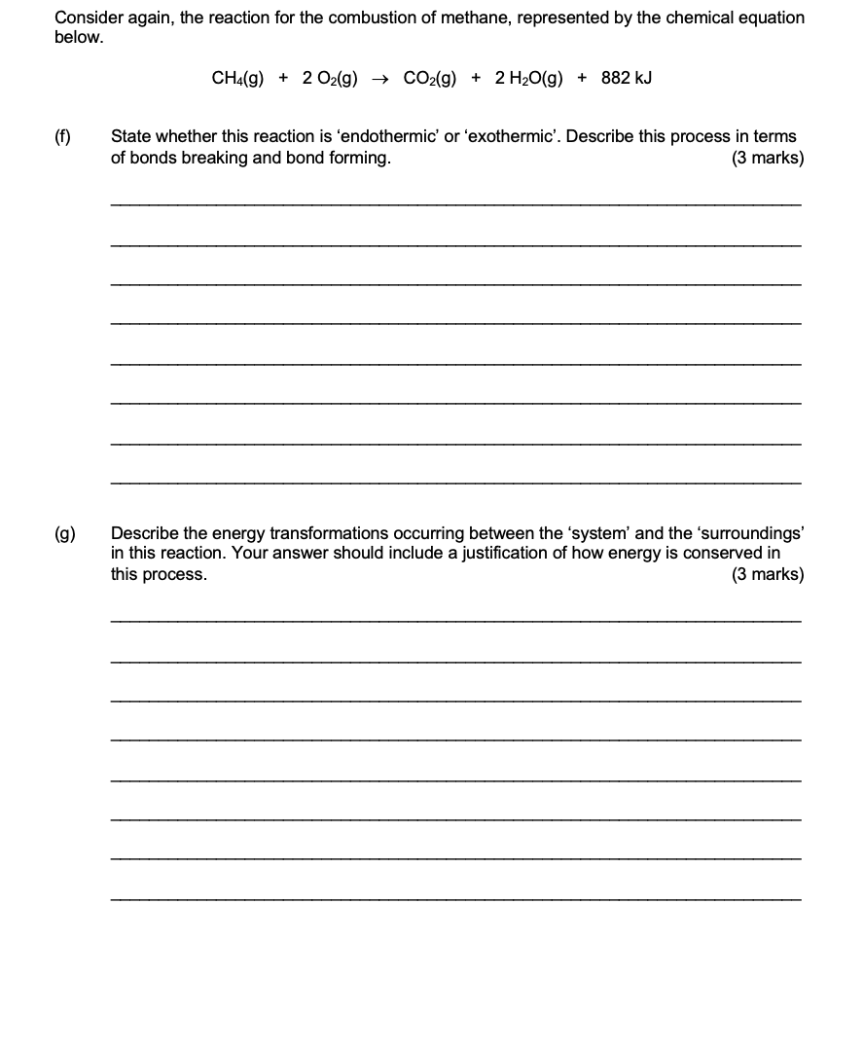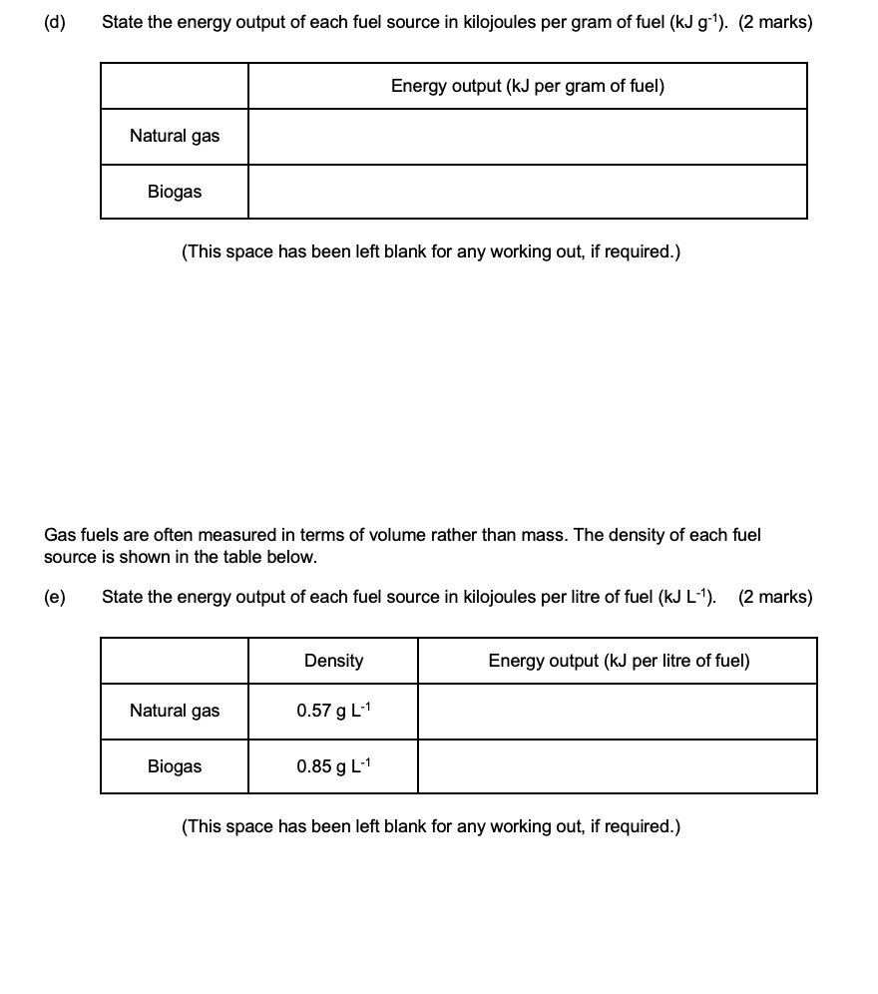

2020 S2

2023 S1

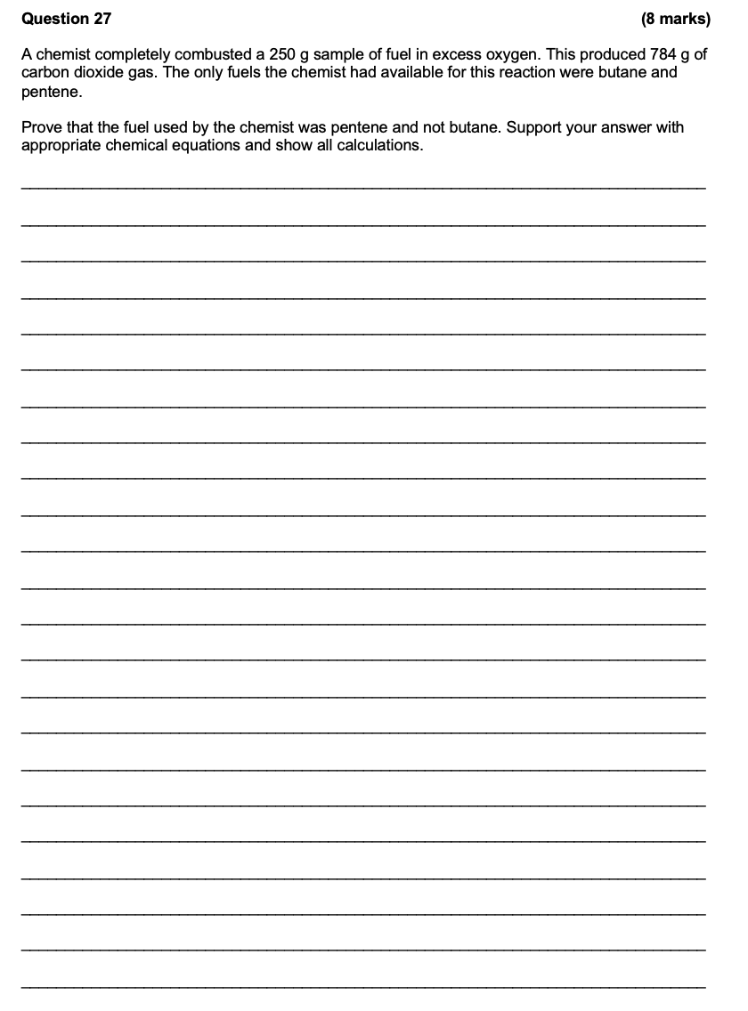

2023 S2

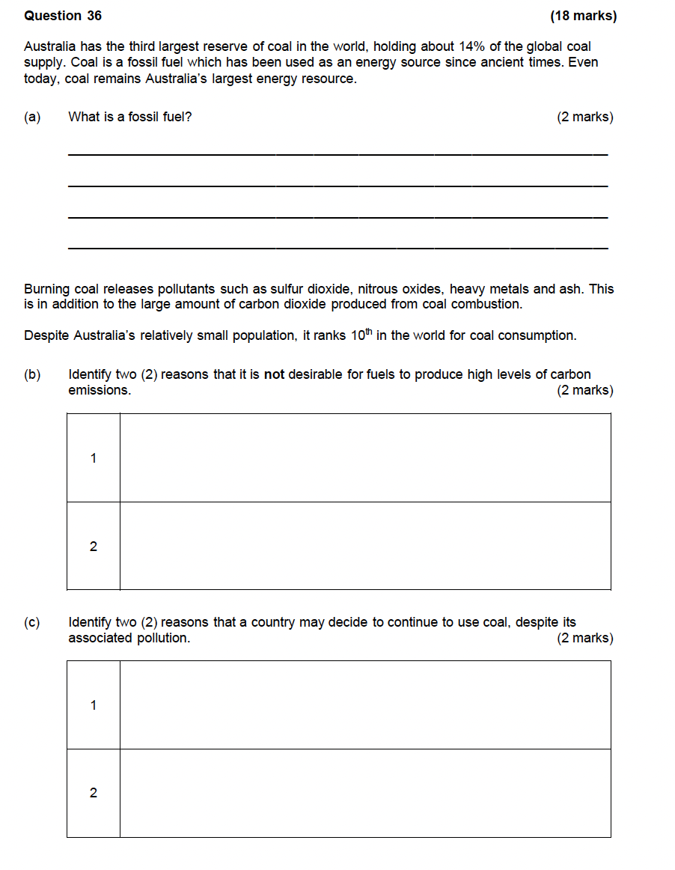
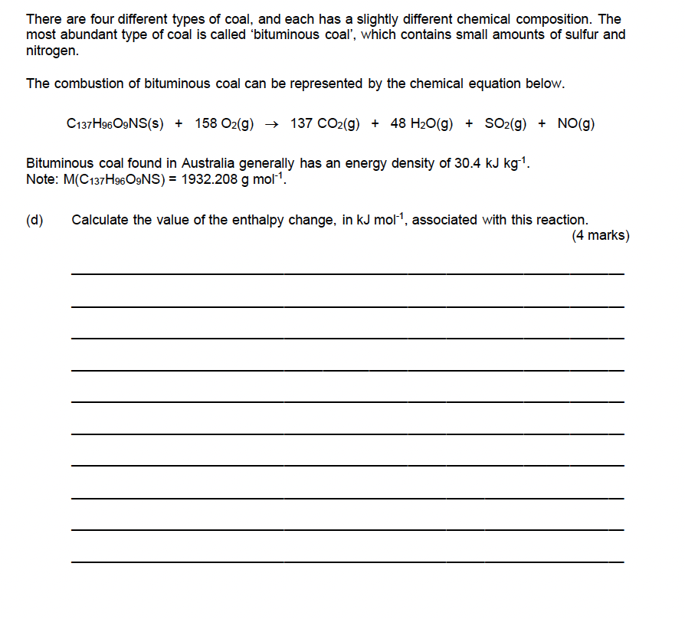
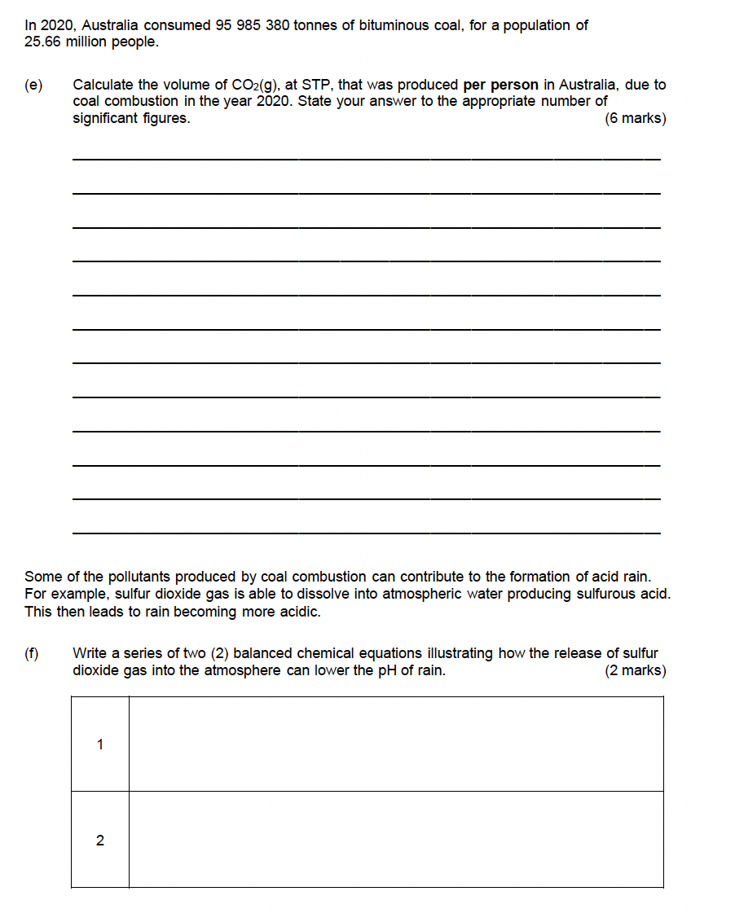

Other Chemical Reactions

2017 S1
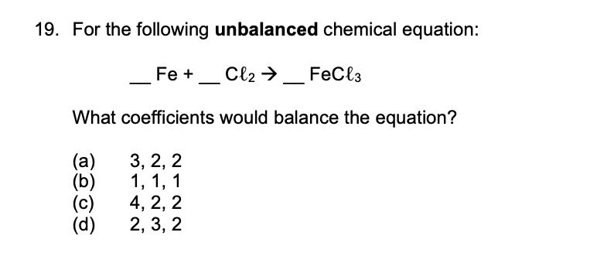
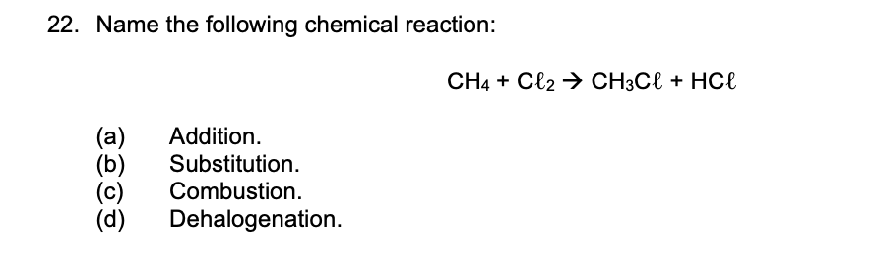

2017 S2

2020 S1

2020 S2
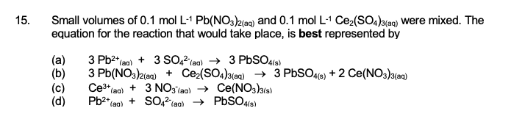

2023 S1

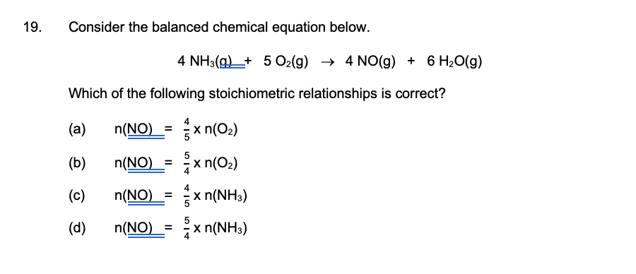

2023 S2

